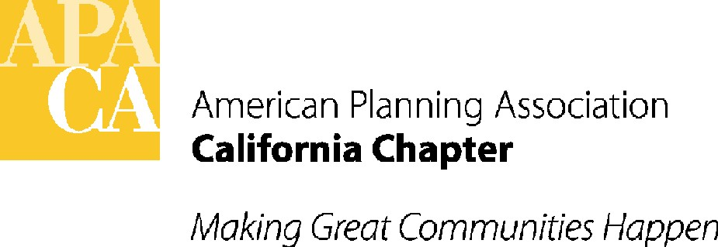

June 20, 2012

Assembly Member Nancy Skinner
Room 4126
State Capitol
Sacramento, California 95816

SUBJECT: OPPOSE UNLESS AMENDED AB 904 (SKINNER) – MINIMUM PARKING REQUIREMENTS – IN SENATE GOVERNANCE & FINANCE- WEDNESDAY, JUNE 27TH

Dear Assembly Member Skinner:

Although APA California very much supports reduced parking standards for infill development in transit rich areas, we must respectfully oppose AB 904 unless amended. AB 904, as presently drafted, would restrict local agencies’ ability to require parking in excess of state-wide ratios for transit intensive areas unless the local agency makes certain findings and adopts an ordinance to opt out of the requirement.

We appreciate your staff and the sponsors meeting with us to review our concerns and questions with the current version of the bill, and wish this dialogue could have occurred earlier in the process. While APA California supports the reduced parking concepts underlying the bill, we also have a number of concerns with the process and specific language that is used in this bill, and don’t believe as written it will accomplish the sponsors’ goals. Specifically, the parking minimums are so strict that most jurisdictions will exercise the opt-out provisions rather than undertaking a meaningful reassessment of parking ordinances.

APA California looks forward to continuing the dialogue with you and the sponsors to develop a proposal that meets both the sponsors’ and APA California’s objectives.

Below are the specific concerns that APA California has identified with AB 904 as recently amended:

Basic issues:

- SINGLE STATEWIDE STANDARD: The goal of having reduced parking in the right places is a good one. However, given the huge diversity of cities and counties in California, local conditions vary and a single statewide standard undermines the ability of individual agencies to take into account their unique situations. Further, agencies around the State are considering these important issues and updating parking standards through revised parking ordinances and flexible standards that can be authorized by discretionary review.
- OPT-OUT PROVISION: Requiring most jurisdictions to exercise the opt out provision because the parking standards are too strict subjects local agencies to an unnecessary and complex process of defining objective criteria, documenting findings and complying with ordinance adoption requirements. This exposes agencies and project developers (as real parties in interest) to lawsuits, fails to account for those agencies that already have low parking standards but which still don’t meet the arbitrary standards in the bill, and does nothing to assist local agencies that have not yet revised parking standards.
- DEFINITION OF TRANSIT INTENSIVE AREAS: Transit intensive areas should be served by actual and usable transit options in urban infill areas, not minimal or planned future transit facilities or services that are currently included in AB 904.
- ONE COMMERCIAL PARKING MINIMUM: Requiring only one parking space per 1000 square feet of nonresidential project area is particularly problematic. This requirement treats a stadium, a Safeway, a park and ride lot, medical offices, a small café, and many other categories of commercial use in the same way. The bill should instead focus on residential and mixed-use projects, which are more similar across jurisdictions and more typical infill projects.
- PARKING MAXIMUMS: Bill proponents say that AB 904 does not create parking maximums. While strictly speaking this is true because developers/project proponents have the ability to propose as much parking as they see fit, local agencies are precluded from requiring more parking than the statutory rates unless certain extra steps are taken. APA California does not agree that developers should be granted latitude while local planning experts and decision makers are afforded no such latitude.
- EXISTING LOW PARKING STANDARDS: Many jurisdictions in the last few years have adopted thoughtful parking ordinances to reduce parking requirements. Such efforts should be recognized and those agencies should be given credit for current parking programs.
Examples of cities with reduced parking standards include:
- The City of Sacramento is near adoption of changes to their parking regulations, which are proposed to substantially reduce or eliminate many of their parking ratios.
- The City of Pasadena had enacted a Parking Credit program, which allows a developer to build a larger parking option and charge other developers for use of those parking spaces so their projects do not have to individually provide parking. This bill could leave the developer with the parking footing a very large bill.
- The City of LA has adopted its Adaptive Reuse Ordinance that substantially lowers parking requirements and has been used as a good parking standard example by proponents of the bill. However, the 1.3 parking spaces per dwelling unit, on average, suggests that the proposed parking standards in the bill may be too low.
- San Bernardino is considering a transit overlay district with alternate development standards.
- LOCAL COASTAL PLAN CONFLICT: Cities and counties in the coastal zone with LCP’s must have any parking ordinance approved by the Coastal Commission. Historically, the Coastal Commission has rejected efforts to substantially reduce parking, weighing in on the side of more parking to ensure continued public access. Because of this, it is unclear which would take precedence.

Specific Concerns with AB 904 Provisions:

- Page 5, (d), definition of "transit-intensive area": This definition should be amended to eliminate any major transit stop or high-quality transit corridor that is included in a regional transportation plan but not yet operating to ensure that these areas have real alternatives to the use of a car. The bill should also state that it applies to urban infill areas only, perhaps using the SB 375 urban infill definition.
- Page 4, S. 65200 (a). It is not apparent how these parking minimums were determined. They appear to be based on no specific data. Of chief concern is the requirement for one parking space per thousand square feet of any non-residential project regardless of use. Given that most jurisdictions use 3-5 parking spaces per 1000 square feet for uses that require the most parking, such as grocery stores, stadiums, park and ride lots, and medical offices, this assumes that up to 75% of those using the project would be using transit. That is a huge leap of faith and one likely to detrimentally impact projects surrounding these facilities.
- Page 6, (e), 1-4: We appreciate the drafting error correction to allow cities and counties to make one of four findings. This four-finding "out," however, includes language that needs to be clarified. The requirement that the findings be made based upon "objective criteria," which isn't defined, and “substantial evidence” appears to be setting up cities and counties for lawsuits, particularly given that the findings include terms that are undefined. The jurisdiction would have to evaluate each "transit intensive area" in applying these findings. Particularly for larger cities, a single review for the entire jurisdiction makes more sense and eliminates a substantial amount of cost and staff time. This is onerous and burdensome, and undermines the "flexibility" proponents claim. Finding #4 should be amended to be less specific to a single type of plan. It should read: “conflict with a Specific Plan or other adopted plan for the transit-intensive area that is in effect as of…." It is unclear what a "plan that is specific to a station area" means in this context. If "parking standards that create effective incentives for "transit-oriented development or affordable housing production" apply to Density Bonus law, the bill should clarify that.
- Page 6, (f): Adoption of an ordinance would have to comply with CEQA. Would an ordinance increasing parking requirements above the state minimum require an EIR? Could the statute include a CEQA exemption? The bill should also clarify that adoption of the ordinance is not required for each transit-intensive area. The timeline to approve the ordinances within one year or subject all projects to the parking minimums in the bill is extremely tight, particularly if the ordinances will be subject to CEQA. A three-year implementation date for the bill would be more realistic. We question whether an ordinance is the proper vehicle for opting out. A resolution, perhaps after a public hearing, would be a more appropriate, less time-consuming process. Further, it would allow for delegation to a Planning Commission if an agency deemed that appropriate.

As noted above, we remain willing to work with you and the sponsors to clarify these issues, as well as work on an alternative that focuses on residential and mixed-use projects.

If you have any questions, please contact APA California’s lobbyist Sande George, Stefan/George Associates, at 916-443-5301, sgeorge@stefangeorge.com.
Sincerely,

David Snow, AICP
APA California, Vice President for Policy & Legislation

cc: Members of the Senate Governance & Finance Committee
The Governor
The Office of Planning & Research

